Congregation

* Creation of Province – the option of District and place may not be required. Provinces are directly under Generalate so no need to give this option in the Province.

Creation of Diocese

* The name of the Diocese should be the first box and then the other details. Dioceses are in different countries and in the same diocese there are multiple provinces working, hence the selection of the Province may not make sense.

Common houses

* The first option is to be selection of the Province. Then the district and other details.

Member add

When the member is added and edited province it does not get displayed in the Home Button. I don’t know, if it is safe to give the editing of the Province as the history of the province is to be maintained so may be good that we restrict and allow only the transfer of the province. I am happy about the change of the province in the member add or edit if it does not create any problem.

To search the members I think you need to give additional options like selection of the members based on the province as the list is too big to search as the numbers will be over 1000 and similar names will create problems. I understand that this option is used only once at the time of registration…

Member details entry

When entering data after saving or adding the record the page is out of the present member and not able to continue with the entry of the other tabs like formation, family, etc.

When the field is empty without even selecting a member it allows to enter the data and after that it gives error and software gets hanged.

Better management of error control to be thought off.

Login Track

The time of the login along with the place, country of login, etc. to be registered. It is mainly to track the unauthorised attempts of login. If it is too difficult then don’t worry about it.

Under user permissions

There need to be an option for add edit view delete , etc. options. Some using will have only view options while some others will have the permission to edit and a specific user for delete, etc.

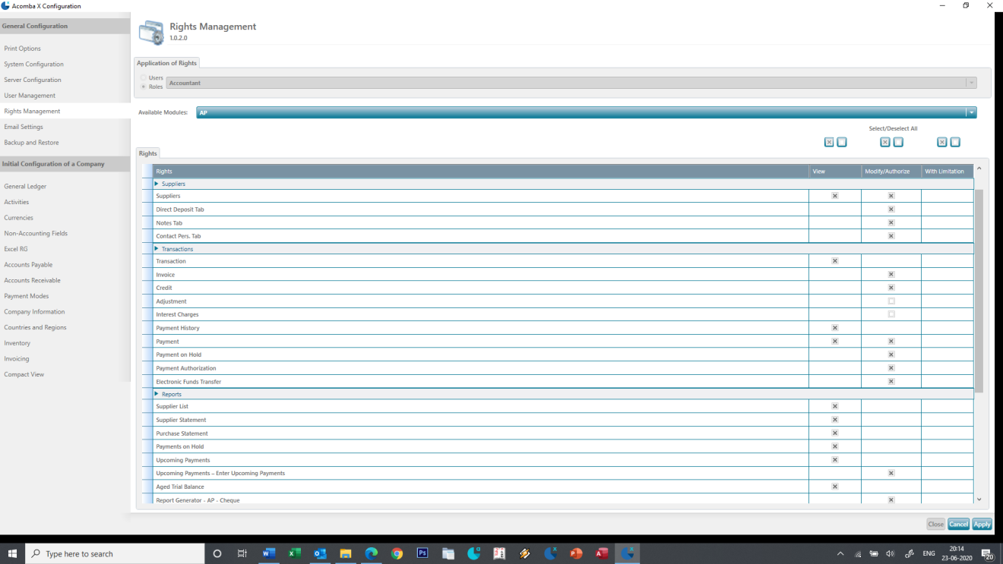

26-06-2020

Primary details

When we select and enter after selecting the name of the person, the primary details should be displayed in the page and enable to be edited only when the edit button is clicked.

27-06-2020

When we are entering the email the normal format of the email to be mentioned, etc. if the user enters a wrong format like without @ then it should give a warning to check the email. This field need not be compulsory.

In the primary data under date of Birth (in bracket you have mentioned Baptism). Date of baptism is not the same as date of Birth. If you have difficulties to modify the same then we could add under sacraments like the Baptism, confirmation, etc. since we have already made a tab for sacraments.

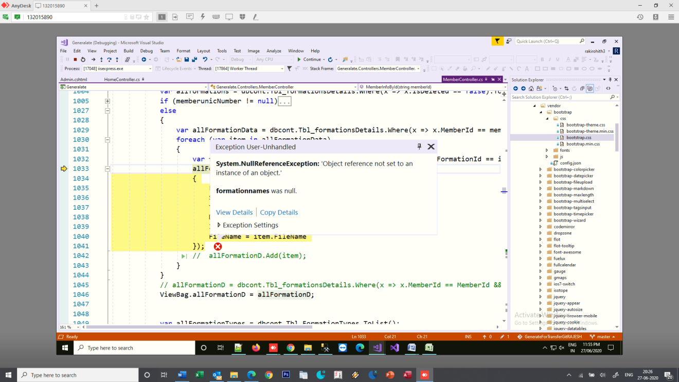

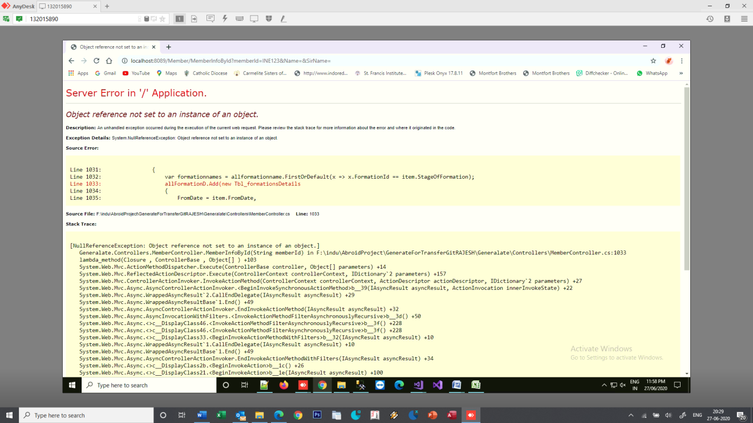

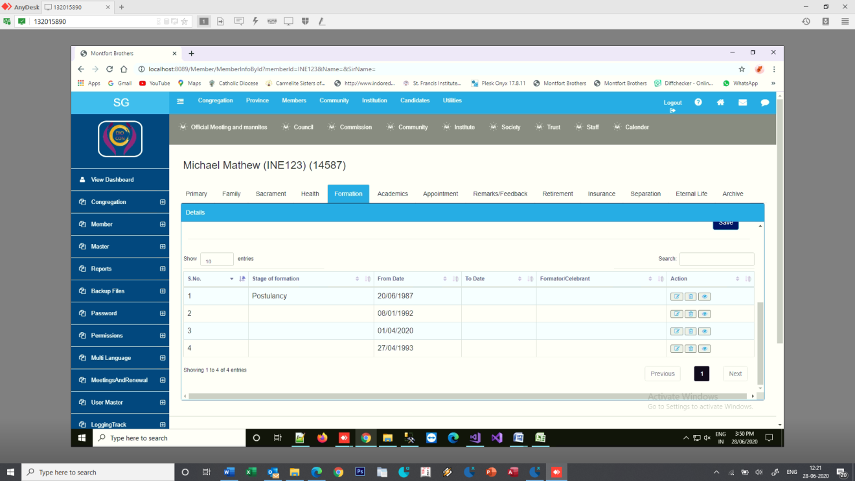

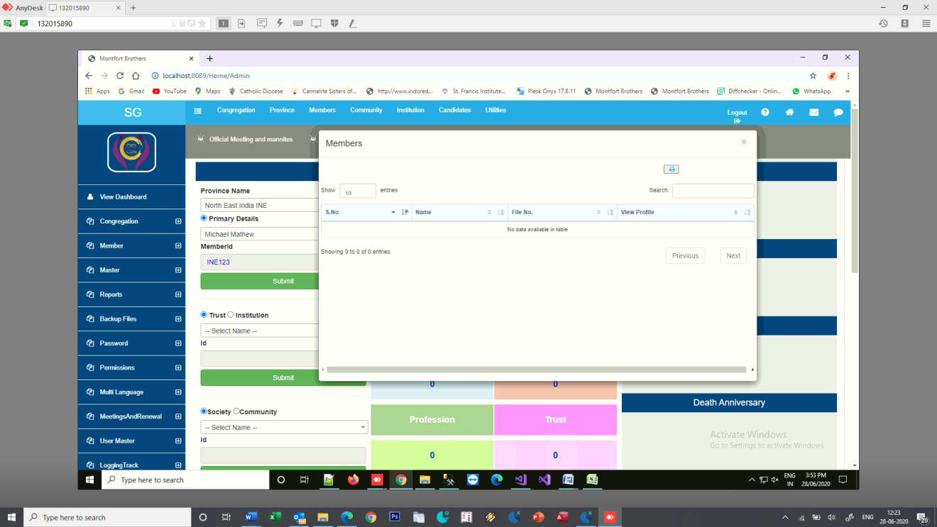

28-06-2020

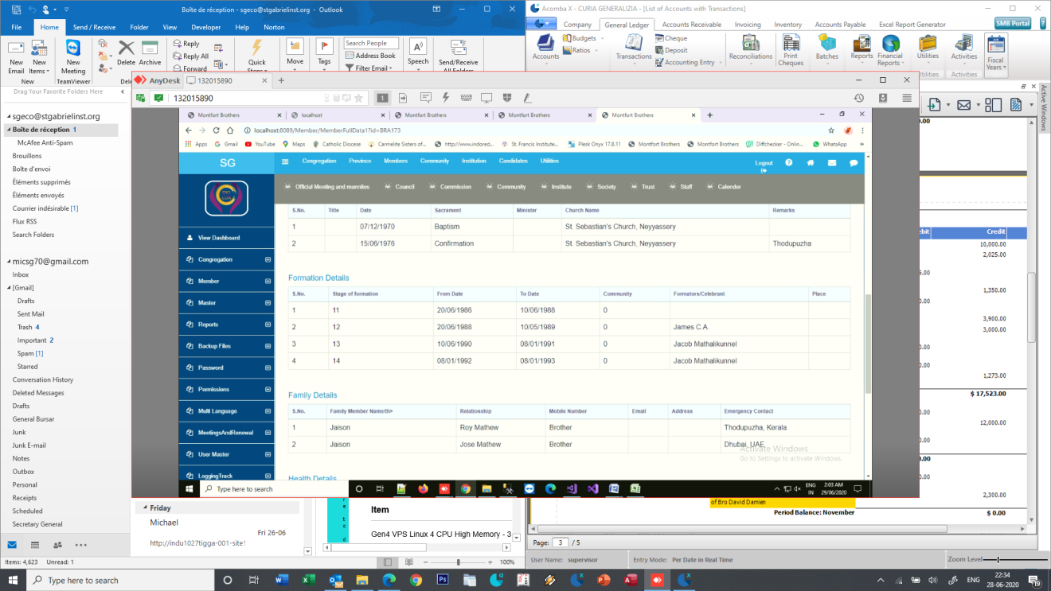

The stage of formation is displayed as number and not the Value

29-06-2020

Under Congregation – Common House

The order to be like

Province – which is to be dropdown as selection of the Province

District – selection of the districts

Outside Congregation

If the selection of the Province of the Congregation then the list of the Provinces could be displayed for selection as dropdown.

When adding or editing the Diocese the message is displayed as some error occurred. The data gets updated.

In the dash board

When I select the Province – the member details are shown as O while there is an entry and it shows under professions

The diocese gets deleted even though there is a corresponding entry made under Communities. And the diocese becomes blank – if there are corresponding entries it should not be allowed to delete it unless the corresponding entries are removed. This is to be checked for all the dropdown entries.

When I click on my community options under dashboard it goes to official meeting. When entering the Community the hierarchy of Province, Disctrict , etc. to be followed for the Generalate. I understand that it is alright for the Provinces but for the Generalate when we create we need to have an option to choose the province, District, etc.



The community ID is displayed as in the database with characters - 418ea0d6-7e84-ea11-8324-8cec4b7a5447

When I click on the Society it goes to Governing Body members . the tabs for the entry of Society, Community, trust, etc. ?????

In the dashboard when we select the Generalate the options to enter the community, society, etc. gets appeared.

When we enter a community and wasn’t to add a diocese it gives an error as given below

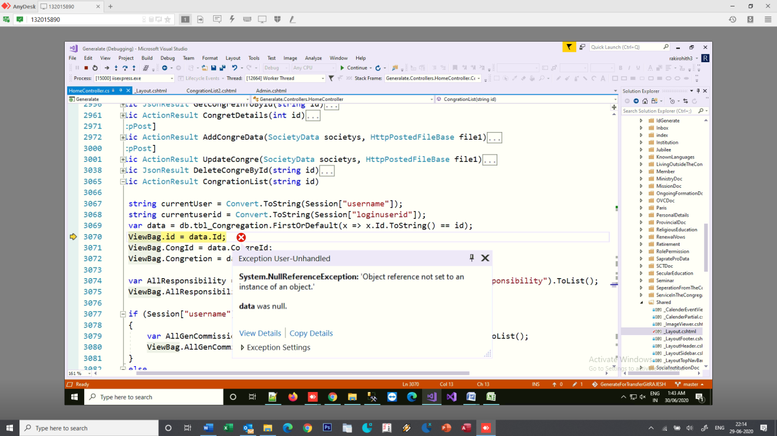

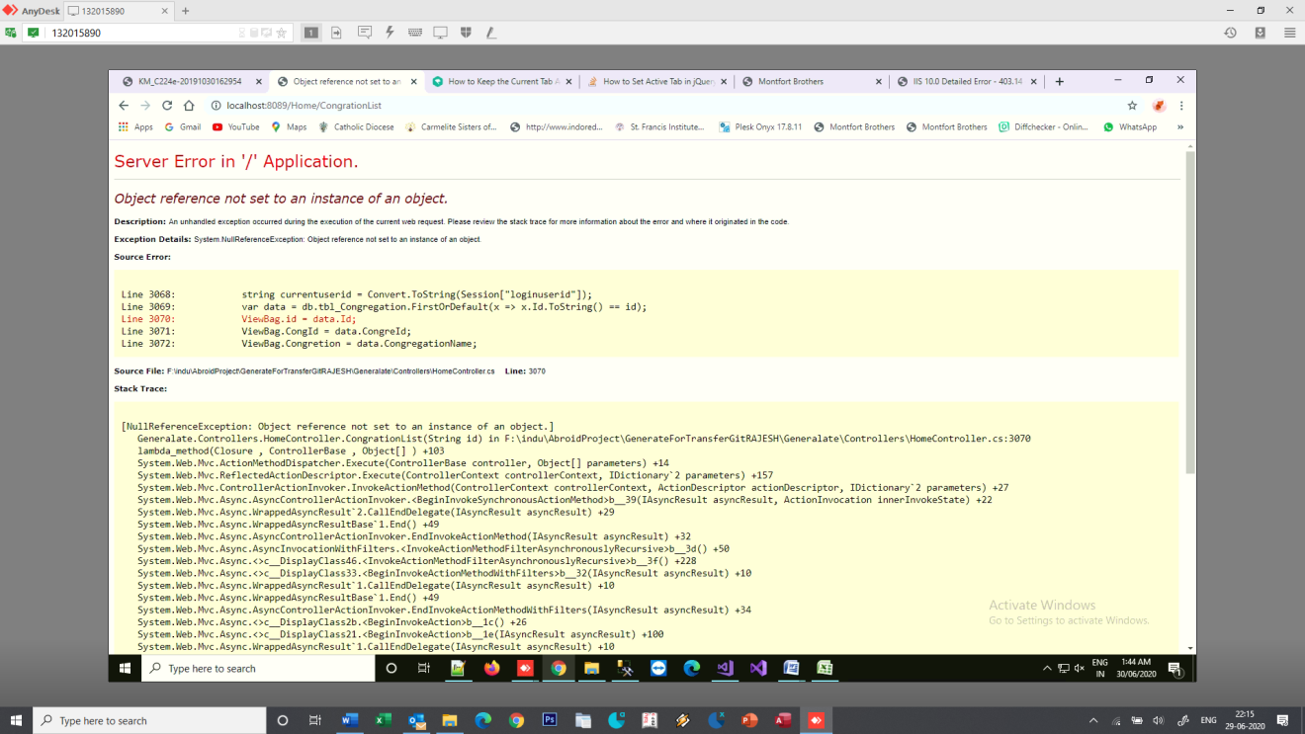

When editing the community details it gives error

